**CMP 4271: Session 2 Online Diary – Employability Game**

* In our game, the player wants to obtain more skills than their opponent(s) before the “Job Interview”, which is the end of the game, in order to get the job.
* To make the game, the materials needed are a board, counters to show where players are on the board, a pair of dice, 5 cards stating the possible jobs that the player is “interviewing” for and 12 cards for the 12 available skills to collect.
* The rules of the game are as follows:
  + 2-6 players split themselves into teams depending on the number of players (2-3 teams recommended).
  + Pick one of the five cards detailing which job the players will be interviewing for, and which skills are required. The player/team with the most skills out of those stated on the card will win the game.
  + Each player/team starts from the “START” position (shown in Figure 1) and rolls the dice. Whichever player/team rolls the highest number goes first and moves that number of spaces. If both teams roll the same score, roll again until one team scores higher than the other.
* 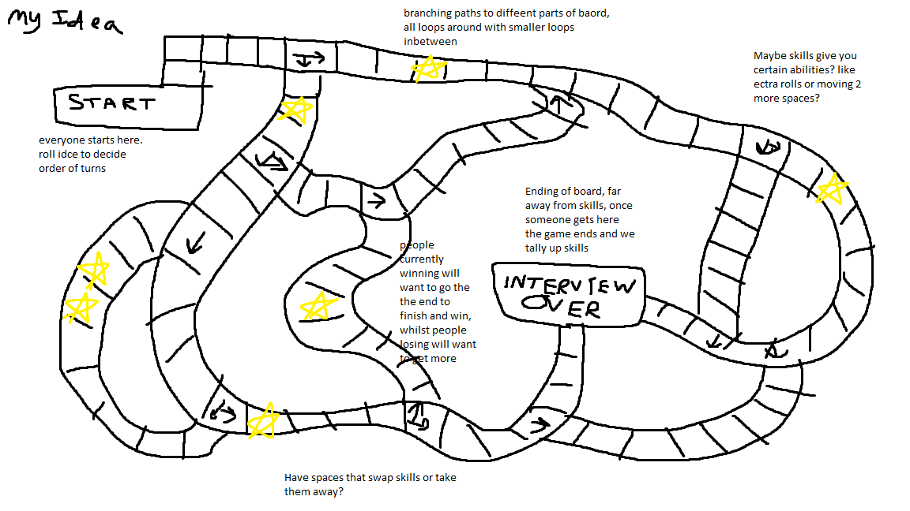xdgh

Figure 1. A design of the layout of the board including the “START” area (A), the “INTERVIEW OVER” area (B), and Gold Stars (C) to show potential areas where Skills can be obtained.

C – A square with a Skill in it

A – START area

B – INTERVIEW OVER space